# Hand Gesture Recognition using RGBD

深度相机类型:

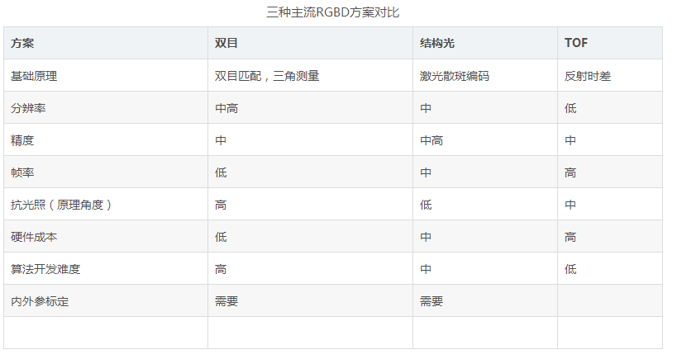

深度图像的特点: 空洞性 噪声



基于深度相机的手势识别方案:

• Hand extraction 手部的分割

• Feature extraction 手部骨骼的提取或其他

• Gesture classification 训练和分类：随机森林，HMM

1. **从复杂的图像和深度信息中分割出手部。**

RGB方案有：基于肤色的方法和基于外形的方法。

深度信息：简单的阈值法（前提是手部处于相机最前面的假设）；

Color data can be combined with the depth in order to improve the accuracy and better segment the hand from the arm. Once the hand is detected, the arm is removed by exploiting the depth and other geometrical constraints.

2．骨骼提取或者进一步分割手（手掌，手指，指尖）

To perform per-pixel classification, a novel depth-context feature is proposed to describe

the local depth contrast for each pixel, based on which a trained RDF classifier is used

to assign the part labels.



来自：Hand Parsing and Gesture Recognition with a Commodity Depth Camera

**3．Extraction of the Relevant Features**

• **Distance features**: 3D distances of the fingertips from the estimated palm center. 指尖距离手掌和指尖之间的距离

• **Contour histogram features**: account for the contour points distances in the performed gesture.轮廓距离特征。

• **Palm area features**: describe the shape of the palm region and helps to state whether each finger is raised or bent on the palm. 手掌特征

• **Connected-components features**: they are based on the connected components in the difference between the hand shape and its convex hull. The dimensions and the number of the connected components can be used as features. 骨骼点连接特征

更多特征定义见：Feature Descriptors for Depth-Based Hand Gesture Recognition

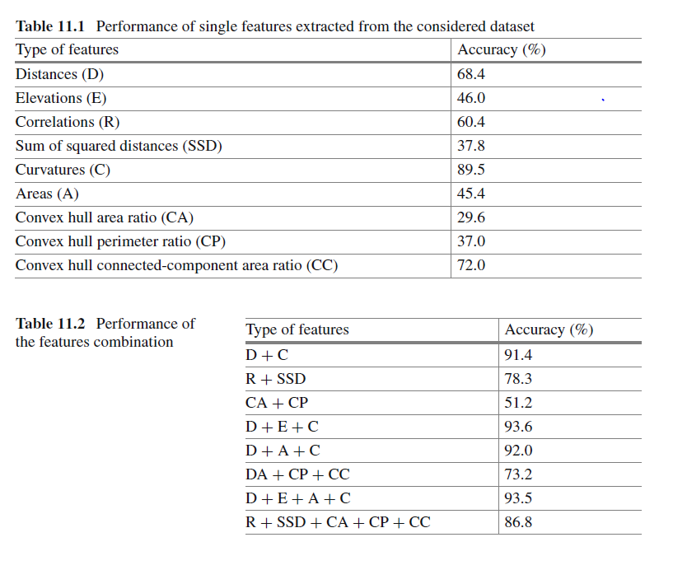

特征之间的组合训练

手势包括静态手势和动态手势。

**静态手势相对简单，将特征送入随机森林或svm等速度较快的分类器中即可。**

动态手势：需要考虑时序建模，一般使用HMM，

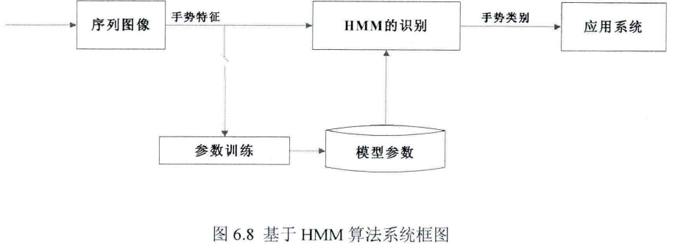

基于HMM的方案

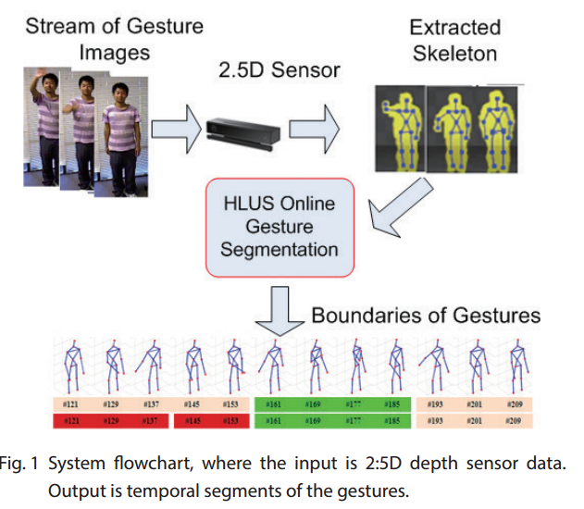

**基于动作片段分割的方案**

We first use Maximum Mean Discrepancy (MMD) criterion [5] is used to capture differences among the distributions of spatiotemporal patterns of the body joints over a stream of continuous gestures. The difference provides estimated cuts of a gesture sequence.

来自：A Real Time Temporal Segmentation Method for Continuous Gestures Analysis

**数据准备方案：**

1. **Marker based**



**2． Synthesized Img（blender poser daz3D）**

